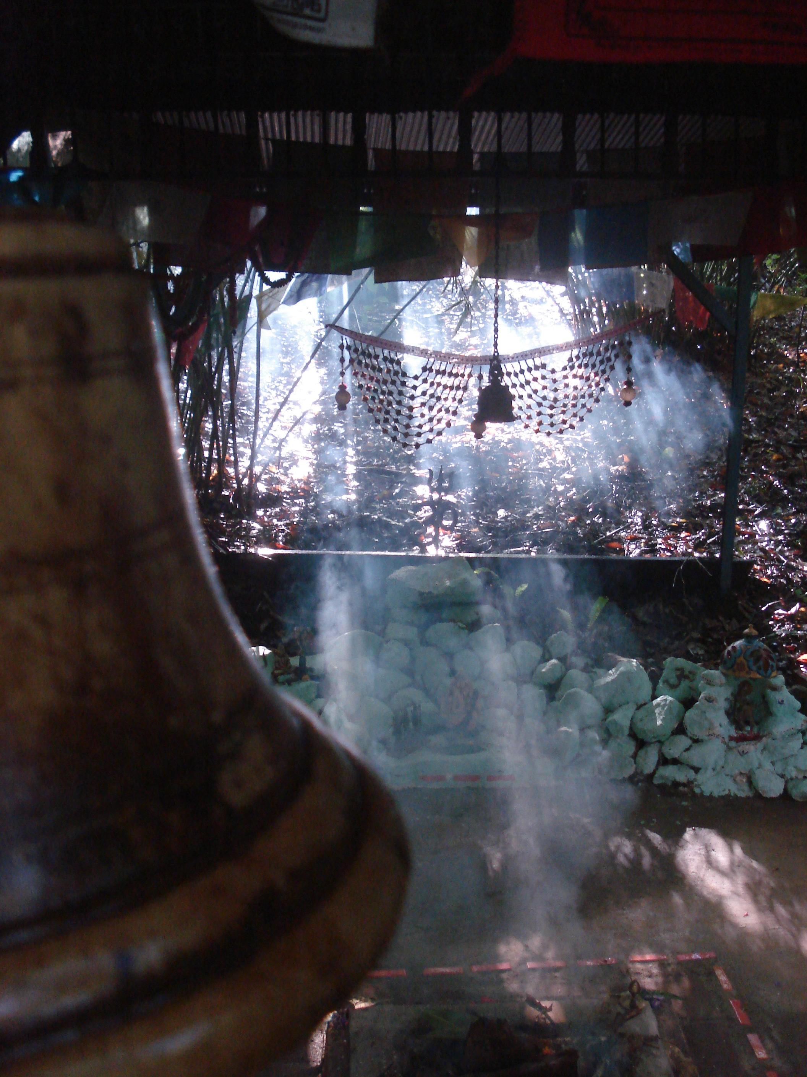

2017 MAHAVIDYA SADHANA

PROGRAM
INTRODUCTION
SADHANA NOTES

Monday 18 Sept. to Thursday 28 Sept. 2017
Mangrove Mountain, NSW, Australia

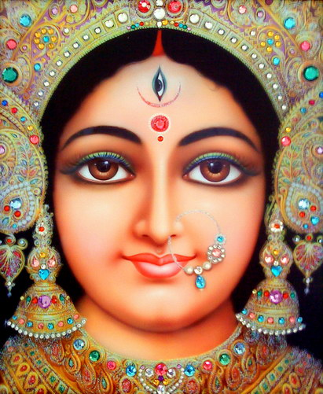

Sankalpa for Navaratri Devi Havan

May all beings be well
May all beings be happy
May all beings be loved
May all beings prosper

.
Monday 18th September
Arrival/ Intro

4pm Arrive
6pm Dinner and clean up
7.15 pm Introduction and discussion (I&D) of Ganesha, Adi Shakti & Kali

Tuesday 19th September
Day 1 – Ganesh and Kali

5.00am Wake up
5.30am Ganesha and Kali havan
Ganapati stotram, Shanti mantra, Agni mantra, Ganesh mantra (OM Gam Ganapati Namaha) x 108, Kali mantra x 108 (Aim Hreem Sreem Kleem Kalike Aim Hreem Sreem Kleem Swaha), Purnahuti mantra, Shanti path
7.00am Breakfast
7.45am Ashram chanting
8.00am Ashram cleaning & karma yoga
9.30am Saundarya Lahari (1 to 24) & 27 x 32 names of Durga
10.30am Morning tea
11.00am Yoga Nidra
12.30pm Lunch and clean up
1.30pm Kali Satsang & Discussion
Colouring yantra chanting mantra and discussion
3.00pm Afternoon tea
3.30pm Free time
4.00pm Kali havan
Devi stotram, Purnahuti mantra, Shanti path
6.00pm Dinner
7.15pm I&D for Tara - kirtan, storytelling & chanting
9.00pm Mouna and retire

Wednesday 20th September
Day 2 – Tara

5.00am Wake up
5.30am Tara havan
Ganapati stotram, Shanti mantra, Tara mantra x 108 (Om Hreem Streem Hoom Phat Swaha), Purnahuti mantra, Shanti path
7.00am Breakfast
7.45am Ashram chanting
8.00am Ashram cleaning & karma yoga
9.30am Saundarya Lahari (25 to 49) & 27 x 32 names of Durga
10.30am Morning tea
11.00am Yoga Nidra
12.30pm Lunch and clean up
1.30pm Tara Satsang & Discussion
Colouring yantra chanting mantra and discussion
3.00pm Afternoon tea
3.30pm Free time
4.00pm Tara havan
Devi stotram, Purnahuti mantra, Shanti path
6.00pm Dinner
7.00pm I&D for Tripura Sundari – kirtan, storytelling & chanting
9.00pm Mouna & retire

Thursday 21st September
Day 3 – Tripura Sundari

5.00am Wake up
5.30am Tripura Sundari havan
Ganapati stotram, Shanti mantra, Tripura Sundari mantra x 108 (Hreem Kaeila Hreem Hasakahala Hreem Sakaala Hreem Swaha), Purnahuti mantra, Shanti path
7.00am Breakfast
7.45am Ashram chanting
8.00am Ashram cleaning & karma yoga
9.30am Sri Lalita Sahasranamavali (1,000 names of Devi)
11.00am Yoga Nidra
12.30pm Lunch and clean up
1.30pm Tripura Sundari Satsang & Discussion
Colouring yantra chanting mantra and discussion
3.00pm Afternoon tea
3.30pm Free time
4.00pm Tripura Sundari havan,
Devi stotram, Purnahuti mantra, Shanti path
6.00pm Dinner
7.15pm I&D for Bhuvaneshwari - kirtan, storytelling & chanting
9.00pm Mouna & retire

Friday 22nd September
Day 4 – Bhuvaneshwari

5.00am Wake up
5.30am Bhuvaneshwari havan
Ganapati stotram, Shanti mantra, Bhuvaneshwari mantra x 108 (Aim Hreem Sreem Swaha), Purnahuti mantra, Shanti path
7.00am Breakfast
7.45am Ashram chanting
8.00am Ashram cleaning & karma yoga
9.30am Sri Lalita Sahasranamavali (1,000 names of Devi)
11.00am Yoga Nidra
12.30pm Lunch and clean up
1.30pm Bhuvaneshwari Satsang & Discussion
Colouring yantra chanting mantra and discussion
3.00pm Afternoon tea
3.30pm Free time
4.00pm Bhuvaneshwari havan
Devi stotram, Purnahuti mantra, Shanti path
6.00pm Dinner
7.15pm I&D for Tripura Bhairavi - kirtan, storytelling & chanting
9.00pm Mouna and retire

Saturday 23 September
Day 5 – Tripura Bhairavi

5.00am Wake up
5.30am Bhairavi havan
Ganapati stotram, Shanti mantra, Bhairavi mantra x 108 (Ha Saim Hasakareem Ha Saim Swaha), Purnahuti mantra, Shanti path
7.00am Breakfast
7.45am Ashram chanting
8.00am Ashram cleaning & karma yoga
9.30am Saundarya Lahari (50 to 74) & 27 x 32 names of Durga
11.00am Yoga Nidra
12.30pm Lunch and clean up
1.30pm Bhairavi Satsang & Discussion
Colouring yantra chanting mantra and discussion
3.00pm Afternoon tea
3.30pm Free time
4.00pm Bhairavi havan
Devi stotram, Purnahuti mantra, Shanti path
6.00pm Dinner and clean up
7.15pm I&D for Chinnamasta - kirtan, storytelling & chanting
9.00pm Mouna & retire

Sunday 24 September
Day 6 – Chinnamasta

5.00am Wake up
5.30am Chinnamasta havan
Ganapati stotram, Shanti mantra, Chinnamasta mantra x 108 (OM Hoom Hoom Swaha), Purnahuti mantra, Shanti path
7.00am Breakfast
7.45am Ashram chanting
8.00am Ashram cleaning & karma yoga
9.30am Saundarya Lahari (75 to 103) & 27 x 32 names of Durga
11.00am Yoga Nidra
12.30pm Lunch and clean up
1.30pm Chinnamasta Satsang & Discussion
Colouring yantra chanting mantra and discussion
3.00pm Afternoon tea
3.30pm Free time
4.00pm Chinnamasta havan
Devi stotram, Purnahuti mantra, Shanti path
6.00pm Dinner
7.15pm I&D for Dhumavati - kirtan, storytelling & chanting
9.00pm Mouna & retire

Monday 25 September
Day 7 – Dhumavati

5.00am Wake up
5.30am Dhumavati havan
Ganapati stotram, Shanti mantra, Dhumavati mantra x 108 (Dhoom Dhoom Dhoomavati Phat Swaha), Purnahuti mantra, Shanti path
7.00am Breakfast
7.45am Ashram chanting
8.00am Ashram cleaning & karma yoga
9.30am Saundarya Lahari (1 to 49) & 27 x 32 names of Durga
11.00am Yoga Nidra
12.30pm Lunch and clean up
1.30pm Dhumavati Satsang & Discussion
Colouring yantra chanting mantra and discussion
3.00pm Afternoon tea
3.30pm Free time
4.00pm Dhumavati havan
Devi stotram, Purnahuti mantra, Shanti path
6.00pm Dinner
7.15pm I&D for Bagalamukhi - kirtan, storytelling & chanting
9.00pm Mouna & retire

Tuesday 26 September
Day 8 – Bagalamukhi

5.00am Wake up
5.30am Bagalamukhi havan
Ganapati stotram, Shanti mantra, Bagalamukhi mantra x 108 (Om Hreem Bagalamukhi Sarvvadustanam Vvachammukhamstam Bayajihvam Kilayakilayabuddhinasaya Hreem Om Swaha), Purnahuti mantra, Shanti path
7.00am Breakfast
7.45am Ashram chanting
8.00am Ashram cleaning & karma yoga
9.30am Saundarya Lahari (50 to 103) & 27 x 32 names of Durga
11.00am Yoga Nidra
12.30pm Lunch and clean up
1.30pm Bagalamukhi Satsang & Discussion
Colouring yantra chanting mantra and discussion
3.00pm Afternoon tea
3.30pm Free time
4.00pm Bagalamukhi havan
Devi stotram, Purnahuti mantra, Shanti path
6.00pm Dinner
7.15pm I&D for Matangi - kirtan, storytelling & chanting
9.00pm Mouna & retire

Wednesday 27 September
Day 9 – Matangi

5.00am Wake up
5.30am Matangi havan
Ganapati stotram, Shanti mantra, Matangi mantra x 108 (Om Hreem Kleem Hoom Matangyai Phat Swaha), Purnahuti mantra, Shanti path
7.00am Breakfast
7.45am Ashram chanting
8.00am Ashram cleaning & karma yoga
9.30am Saundarya Lahari (1-103) & 27 x 32 names of Durga
11.00am Yoga Nidra
12.30pm Lunch and clean up
1.30pm Matangi Satsang & Discussion
Colouring yantra chanting mantra and discussion
3.00pm Afternoon tea
3.30pm Free time
4.00pm Matangi havan
Devi stotram, Purnahuti mantra, Shanti path
6.00pm Dinner
7.15pm I&D for Kamala (Kamalatmika) - kirtan, storytelling & chanting
9.00pm Mouna & retire

Thursday 28 September
Day 10 – Kamala & Aarti (Finish)

5.00am Wake up
5.30am Kamala havan
Ganapati stotram, Shanti mantra, Kamala mantra x 108 (Om Namah Kamalavasinyai Swaha), Purnahuti mantra, Shanti path
7.00am Breakfast
7.45am Ashram chanting
11.00am Yoga Nidra
12.30pm Final Feast / Lunch
1.30pm Finish

