Ass 3
Yagia Gentle
Feb 2021

Examination of Nadi Shodhana pranayama on intellectually disabled people presenting with self-injurious behaviour: A Literature Review
.
Introduction
Terms: SI – Self Injurious
SIB- Self Injurious Behaviour
ID- Intellectual Disability

In 2000 the World Health Organisation delivered a report advocating for people with intellectual disabilities (ID) to be included in their societies (World Health Organisation,2001). In the paper’s introduction, the late Professor Stephen Hawking pleads; “we have a moral duty to remove the barriers to participation, and to invest sufficient funding and expertise to unlock the vast potential of people with disabilities” (World Health Organisation,2001 p 9). One hindrance to this potential is self-injurious behaviour (SIB). This may be present due to any number of factors, including frustration due to a lack of communication skills, depression, alexithymia, and anxiety (Moseley et al.,2019). It often causes damage to the person’s body, and may be a precursor of acquired brain injury.(Cooper et al.,2005). A study by van Bogaard et al. (2018) determined that as many as twenty four percent of ID people display deliberate self-injurious behaviour regularly, where self-injurious behaviour is defined as a person deliberately harming themselves physically (Lowe et.al ,2007), and intellectual disability is defined as a personal attribute that displays significant limitations in intellectual functioning and adaptive behaviour (Schalock,2014). Studies suggest that SIB in brief, or extended bouts, is a reaction to disturbing environmental stimulus. However, the protracted episodes are maintained by neurological factors (Thompson & Caruso, 2002). This suggests that relief, or in the best case, recovery, would be through targeting neurological interventions. However, current methods are more geared to restrictive practises such as antidepressants, antipsychotics, and mood stabilizers (Smith, 2005) and a degree of restraint, ranging from verbal commands (LaVigna & Willis, 2002), to mechanical restraint appliances (Duker & Seys, 1997). The adverse repercussions from these interventions range from biological side effects such as obesity, dyslipidaemia, diabetes mellitus, and thyroid disorders (Corall, 2015), to loss of dignity and self-worth (Ye et al.,2018). Current non-restraint practises used for SIB in the general population, such as Cognitive Behaviour therapy, are narrative based, and therefore rarely suitable for people with distorted, or low cognitive abilities and communication skills (Tyror et al.,2003), thus leaving limited options for people with intellectual disabilities. However, there is a yoga practise that may be suitable. Nadi Shodhana pranayama is done by breathing through alternate nostrils in a set sequence, and, as it is worked by merely closing one nostril with a finger for a set amount of time (Bhargava, Gogate,& Mascarenhas,1988), it can be done by the client themselves, or the client’s carer, and has no side effects. Studies by Mishra et al. (2012) explain how this practise displays parasympathodominance and improvements in neurological disorders in control trials. Therefore, the same treatment modality may work with intellectually disabled people presenting with SIB.A search of literature failed to find this important relationship, pointing to a gap in current knowledge. However, this method increases the alternatives available. Kang et al.(2008), explains how for peer recognition, a double blind randomised control trial could test the efficacy of this theory,with the independent variable the SI behaviour, and the dependant variable the intervention of nadi shodhana pranayama, with the study using more than six subjects divided into stratified randomised groups, over a pre-determined time period. This method suits the population, as their diagnosis is unique to the individual (Suresh,2011). Indeed, a lack of motivation to trial this intervention leads to speculative and unreliable information that may dominate proceedings (Rolvsjord, Gold, & Stige,2005).An example is if a person with ID reacts to the discomfort of their medication, and then presents with an SIB through an attempt to communicate the distress. The result may be that they are given an increase in medication, thus causing a cycle of distress for the individual, their support personnel, and the local environment. However, through research into the question “Does regular practice of Nadi Shodana pranayama reduce self-injurious behaviors in people with intellectual disabilities?” we are able to examine a viable alternative that acts to prevent such scenarios.
Yoga is a huge field of science whose potential is only recently being realised. Although it has been preserved in the Indian subcontinent, it was also prevalent in South American, European, and African cultures (Newcombe,2009). Around the first century AD, Patanjali codified the knowledge into the ‘Yoga Sutras.’ This defined the main schools of yoga into devotion(Bhakti), philosophical argument(Jnana), selfless service (Karma), movement of internal energy (Kriya), and movement of energy from external sources (Raja) (Shearer,2020). Nadi Shodhana is one of the exercises of pranayama, the movement of energy through manipulation of the breath, and is from the Raja school of yoga. In his book on the subject, ‘Prana, Pranayama, and Prana Vidya’, Swami Niranjanananda (1998) explains how conscious control of the breath bypasses the medulla oblongata in the brain stem, and is then directed by the higher functioning areas of the brain, causing a reduction in anxiety, and balancing the energy flow in the brain’s hemispheres. This can be verified by following the pathway of stimulus that results in high anxiety. The impression of the stimulus is initially detected by a sensory organ and judged by the thalamus to warrant a reaction to threats and danger. This determines how the hypothalamus and the amygdala react, which then may set off the sympathetic autonomic nervous system to produce a fight or flight reaction (Bishop, Duncan, & Lawrence,2004). However, the stimulus can be analysed prior to a response, thus raising the threshold of responding through bypassing the sympathetic nervous system and responding through the parasympathetic nervous system. The level of the threshold of response is conditioned, yet is able to change through neuroplasticity (Adamec, Blundell, & Burton,2003). This can be achieved through the same conditions as recovering from trauma, such as feeling safe and supported, being able to process past events through communication, and practises such as nadi shodhana, that move the pathway of response from the primal part of the brain to the cerebral cortex area (Weintraub,2012).Therefore, while it may not work in some cases, nadi shodhana pranyama reduces SI behaviour through raising the threshold of response to stimuli. It is a practise that has been used for thousands of years, and is adaptable for intellectually disabled people. The aim of this review is to bridge the gap between the fields of disabilities and yoga therapy in order to alleviate distress in people with ID.

The following is the method and results in pdf format.
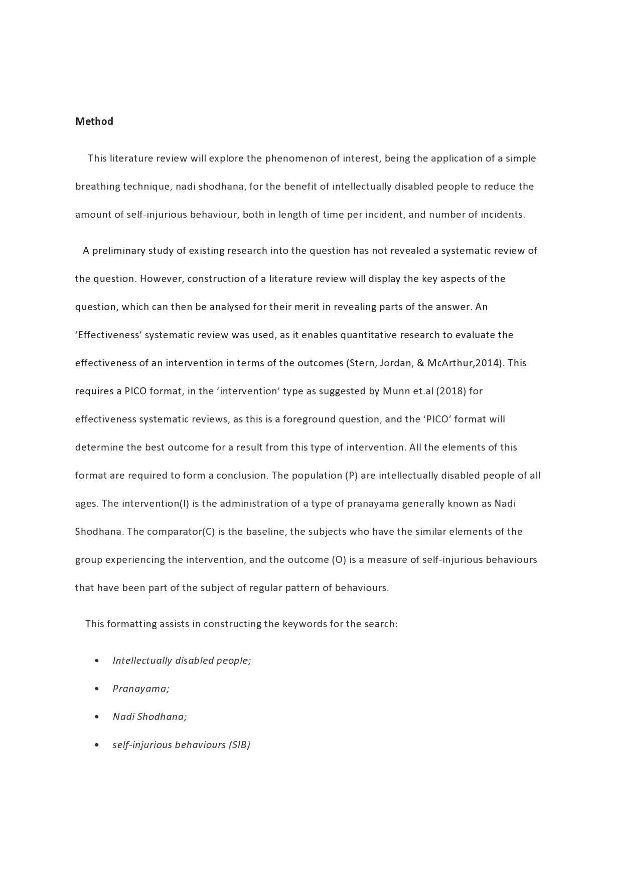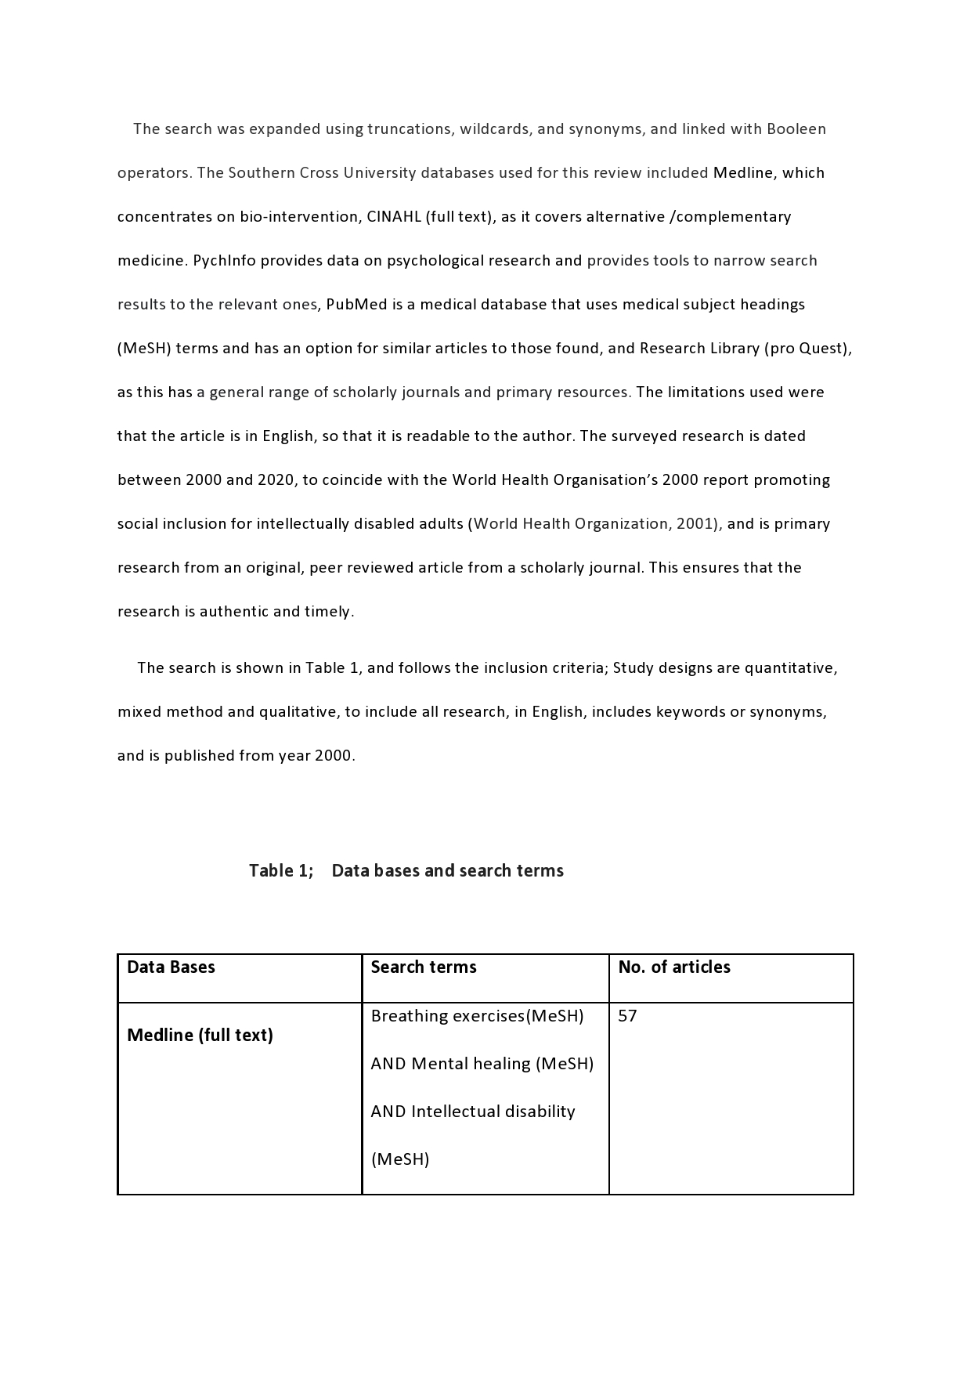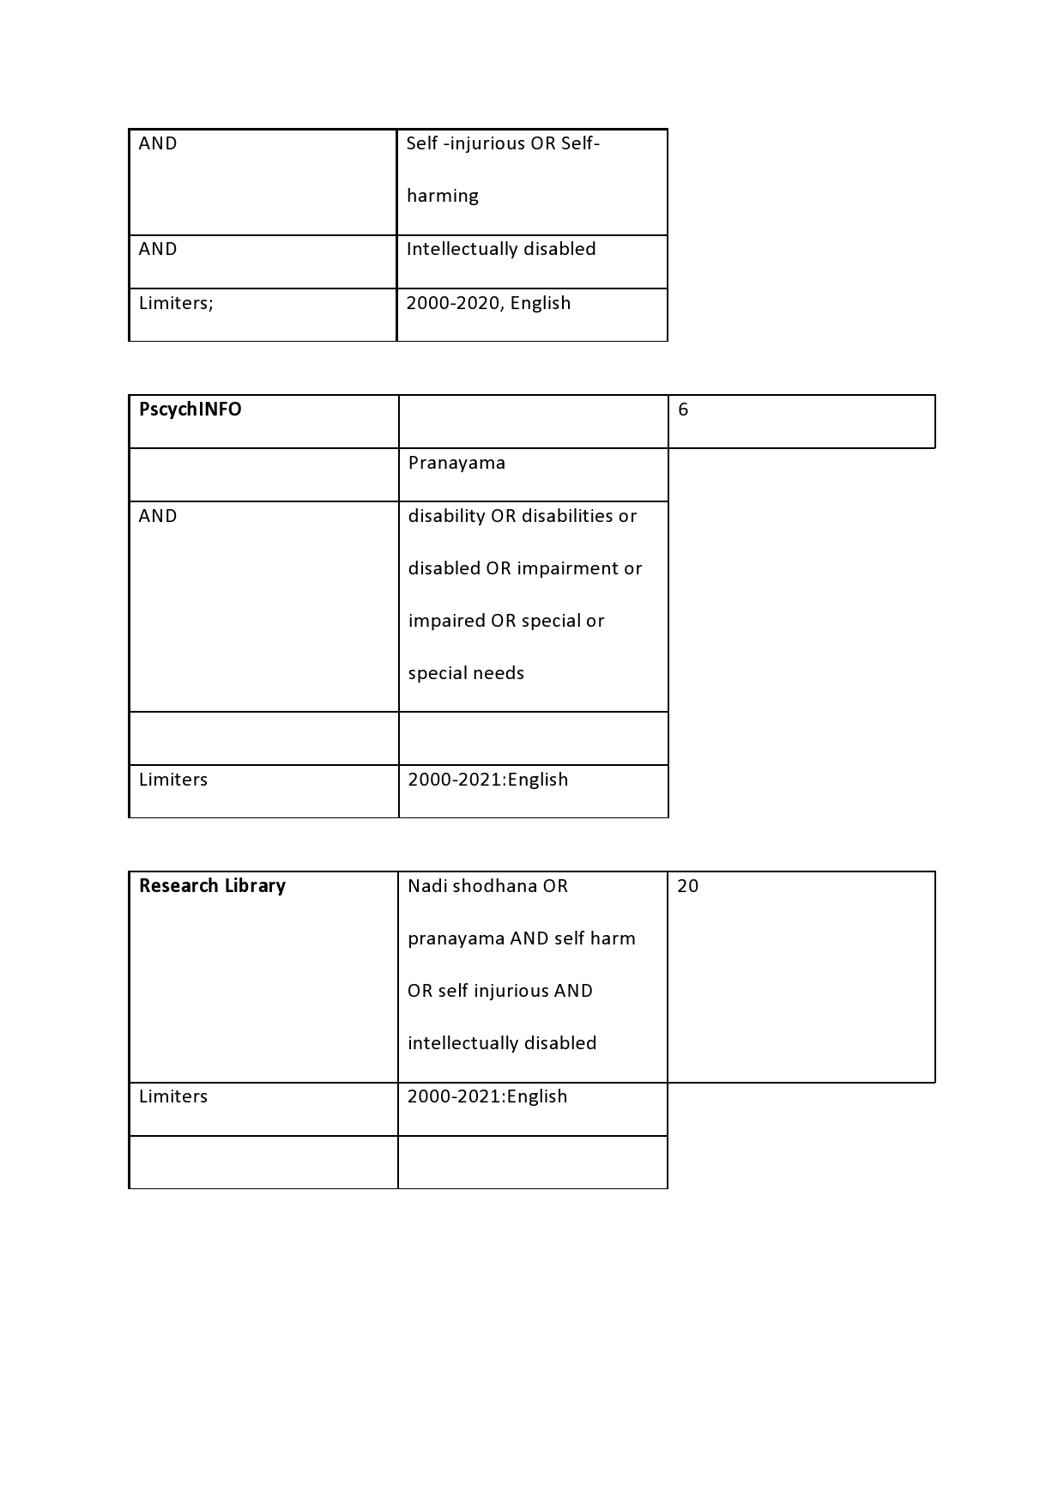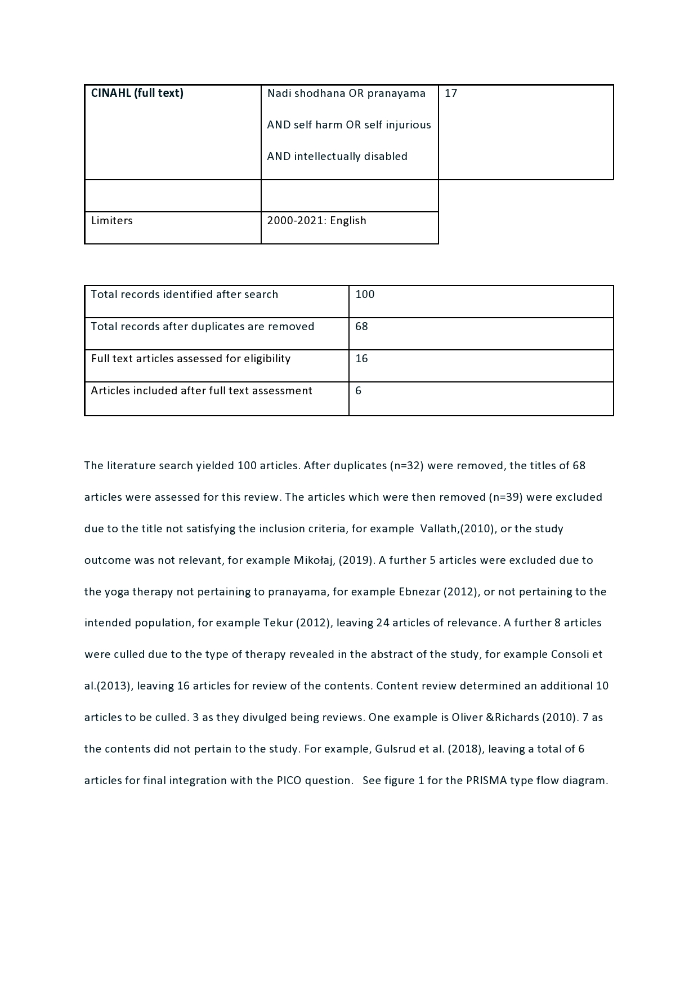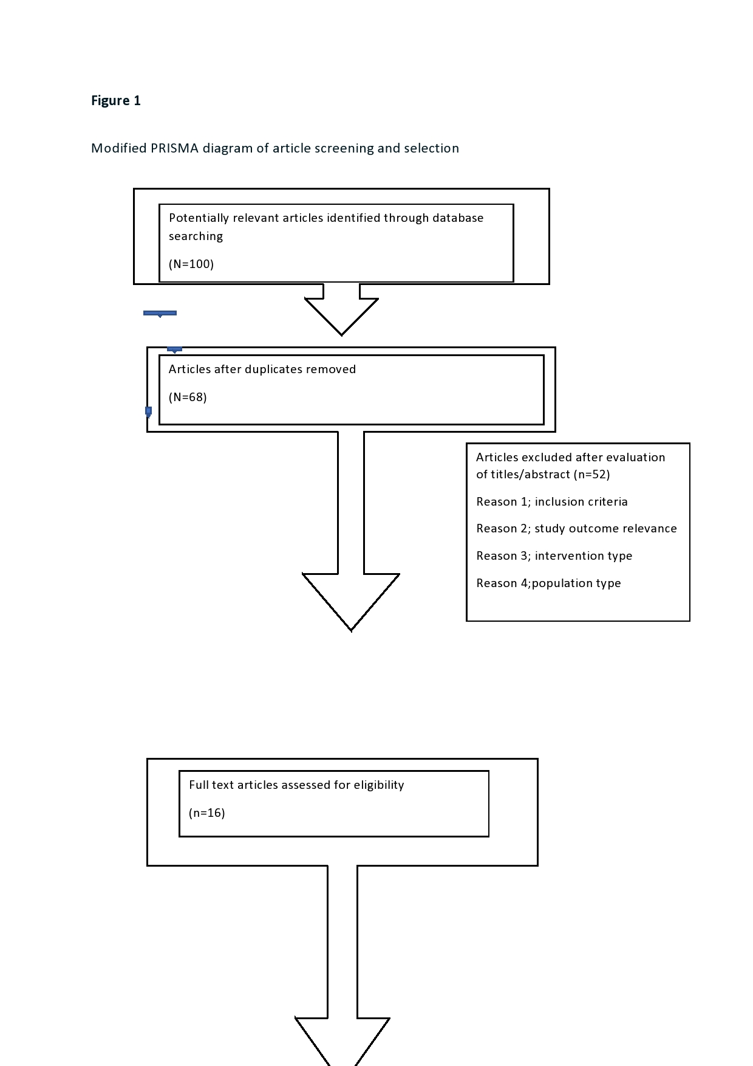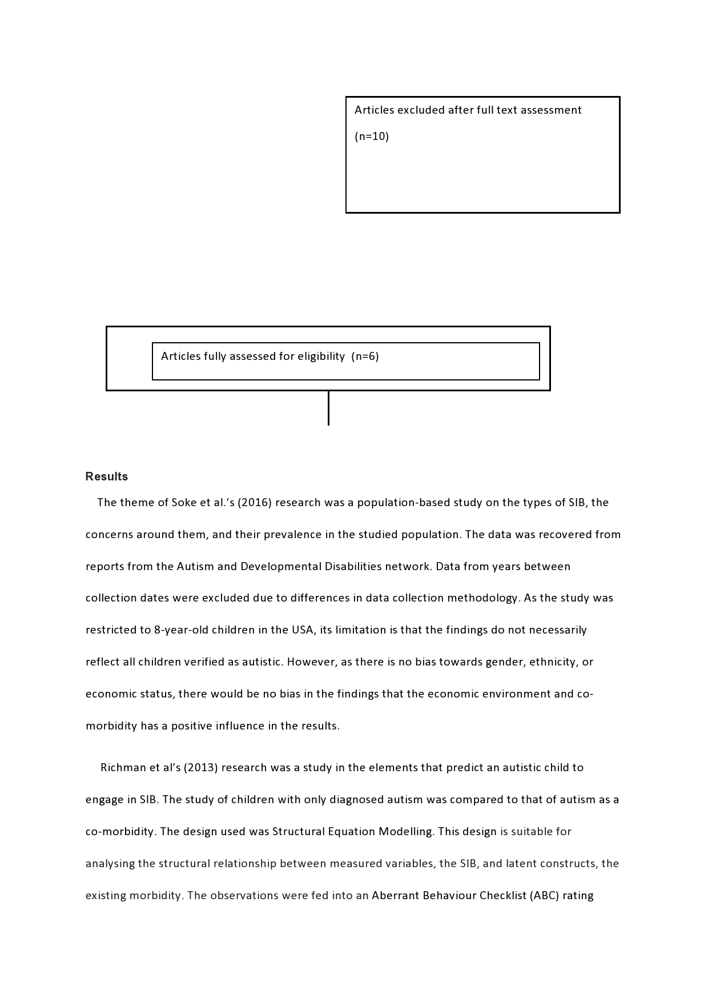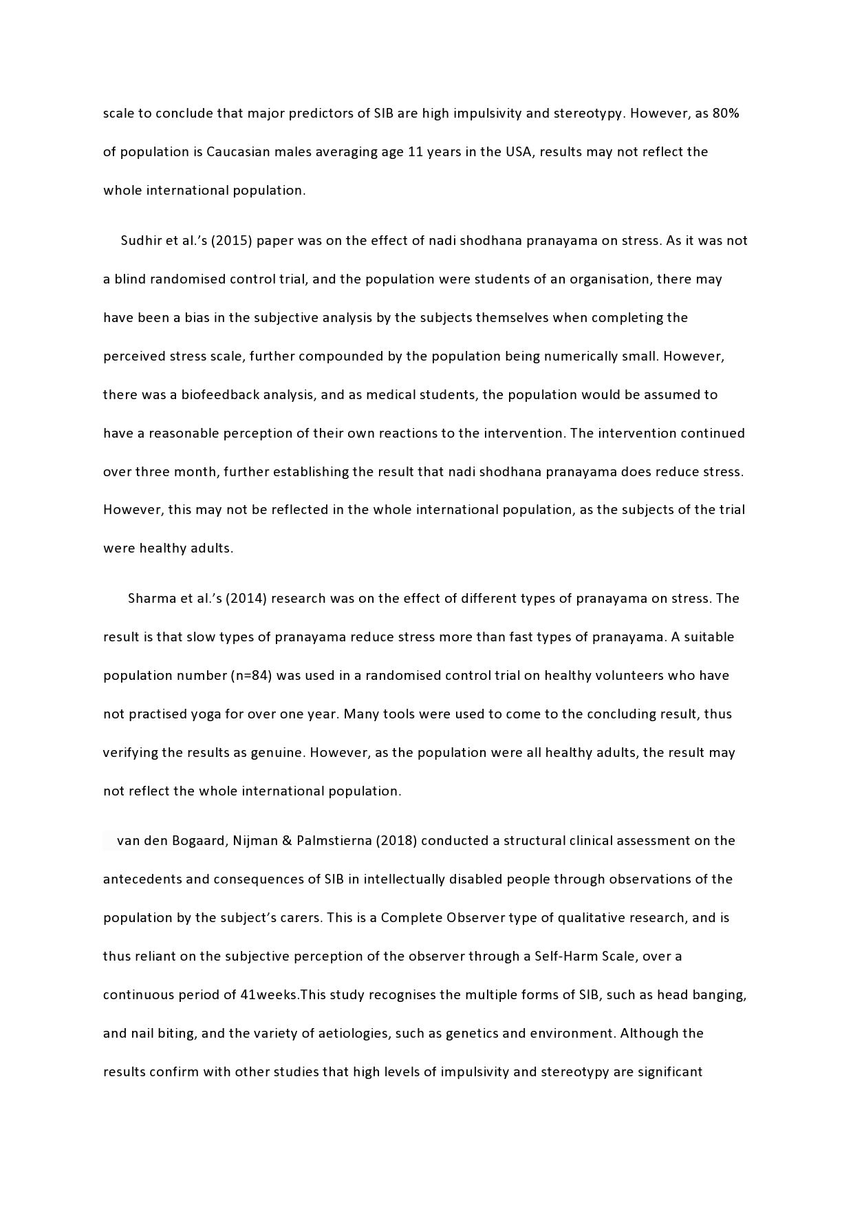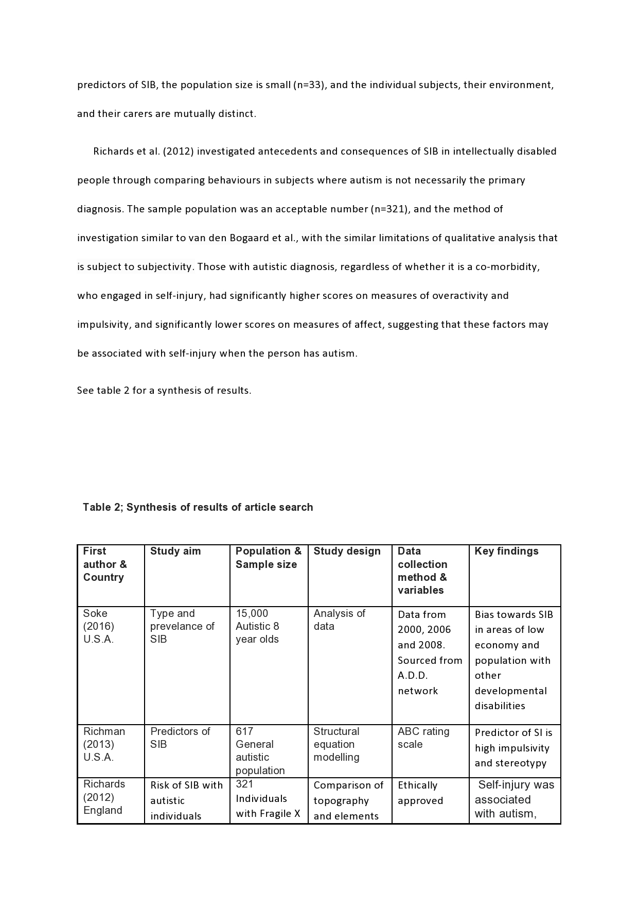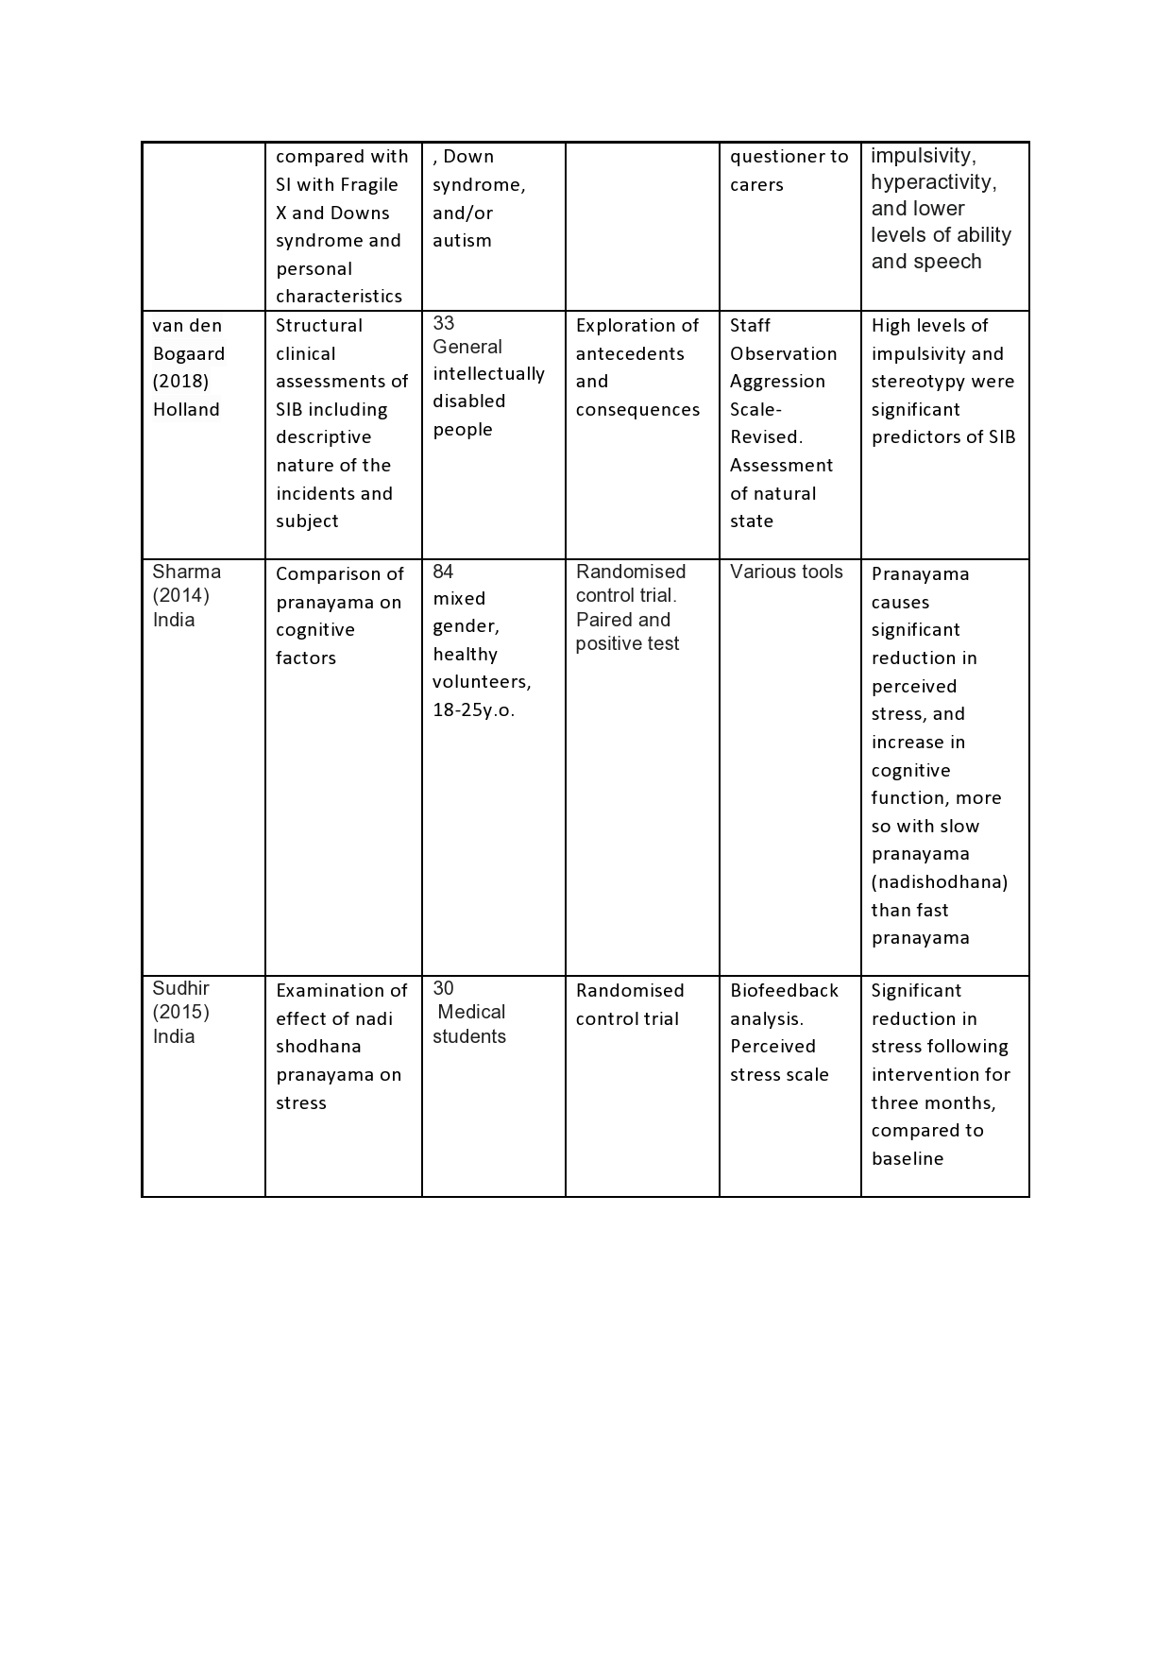

Discussion

Findings from the fields of disability and self-injurious behaviour (SIB) revealed that the predicators and causes of SIB in people with ID have been verified as being high impulsivity and stereotypy, exacerbated by stressors from low-income environments, and the co-morbidity of developmental disabilities. However, there is little research on methods of attack on the predicators of SIB. Papers on SIB among the general population refer to preventative strategies such as Cognitive Behaviour therapy, Dialectic Behaviour therapy, and Gestalt therapy (James et al.,2011).These methods are not suitable for the intellectually disabled community as they require cognition of logic and narrative (Jahoda et al.,2017).
Yoga has many techniques to relieve stress, however, nadi shodhana pranayama is a technique that can be achieved with people who have limited cognitive and narrative skills. Bringing these fields together to form a preventative strategy is the aim of this review of current research. Sudhir (2015) has examined the effect of nadi shodhana pranayama on stress, and found there to be significant reduction. However, this trial was on Indian medical students. The trial assumes that a medical student would be able to follow instructions and have a reasonably high degree of cognitive ability, which would assist in the self-analysis of stress levels. The perceived stress scale could be positively impacted by this feature of the trial, even though a psychometrically valid measure of perceived stress was used (Cohen, Kamarck,& Mermelstein, 1983). However, this concern is largely mitigated by including a biofeedback analysis, which includes measured parameters such as respiratory and heart rate, galvanic skin resistance, and temperature. The conclusion was that, after three months of regular practise, there was a 4.6% increase in relaxation and a 5.53% decrease in stress. These figures are consistent with hearsay and personal testimony from practitioners of yoga (Forfylow,2011), and indicate that the above method may work with other cohorts. This idea is substantiated by Sharma et al. (2014), who examined various pranayama techniques over a three month trial, and proved that both fast and slow types of pranayama are beneficial for cognitive functions. The fast pranayama are beneficial for stress reduction as well as auditory working memory, central neural processing and sensory-motor performance, while the slow pranayama technique of nadi shodhana is more directed at reducing stress. The paper explains this phenomenon through the vagus nerve reacting to stretched lung tissue, resulting in the autonomic nervous system shifting to parasympathetic dominance, which results in a calm and alert state of mind (Jerath et al., 2006). As the findings of van de Bogaard et al., (2018), and Richards (2012) determined that high levels of impulsivity and stereotypy were significant predictors of SIB, it makes sense that becoming calm and alert would mitigate impulsivity and stereotypy through becoming calm and focussed, thus decreasing the incidence of SIB. However, Soke (2016) discovered that a major factor with SIB in intellectually disable people is living in a state of low economy and co-morbid developmental disabilities. This implies a confounding factor in predicating SIB, as this element is not within the control of the studies. Richards et al. (2012), Richman et al. (2013), and van de Bogaard et al., (2018), have focused on congenital attributes, whereas Soke (2016),shows that external conditions are also predicators of SIB. Whether Nadi Shodhana pranayama reduces SIB in all conditions is the subject for further research, although resilience to stressful stimulus in all conditions is possible through regular practise of pranayama (Gerritsen, & Band,2018).
Australian society is now at a point where both yoga and intellectually disabled people are acknowledged and respected. Historically people with any disability, especially those with intellectual disabilities have been shunned, isolated and prejudiced. As recent as the 1970’s this cohort was regarded as ‘idiots, cretins, and morons’(Stigma,2015) and it was only when the Human Rights and Equal Opportunity Commission Act, 1986, was installed that they were brought out of the shadows of institutionalisation and regarded as members of society worthy of respect (Hunt,& Mesquita,2006). Around the same time society has evolved a curiosity and respect for the ancient knowledge of Eastern cultures. Preserved in India, yoga was once regarded as a weird cult in a faraway culture (Antony,2018). It was only with the promotion of yoga around the world by such luminaries as Paramahansa Yogananada in the 1930’s and Swami Satyananda in the 1970’s that yoga has become an acceptable form of body and mind maintenance, and a tool for therapy (Feuerstein,2006). Nadi Shodhana pranayama is one of many pranayama techniques available. Pranayama techniques are designed to raise and balance energy (Niranjana,1998). The methodology is through closing the nostrils in turn with the breath. In its more advanced stages, the breath is held either externally or internally, with the inhalation and exhalation held in ratio with the incoming and outgoing breath. As it requires minimum guidance, and can be accomplished by anyone, it is suitable for any degree of intellectual disability. Only a few studies have been published on the benefits of nadi shodhana pranayama, most of them from India, as this country has encouraged research on the benefits of yoga. Indeed, Prime minister Narendra Modii successfully lobbied the United Nations to have declared June 21 as the International Yoga Day, and helped to set up yoga research bodies. Field (2011) published a comprehensive review on the somatic and psychosomatic benefits of yoga and came to the conclusion that yoga needs to be included in the mainstream medical community. However, she pointed out several limitations on yoga literature, citing over compliance of the trial’s participants, lack of randomisation in some studies, and significant variability in measurement methodology. Some of these concerns can also be attributed to studies in this review. Indian culture stresses the importance of compliance to authority (Pellegrin et al.,2010), and as both Sudhir et al. (2015) and Sharma et al. (2014) had Indian subjects who were volunteers or medical students, their level of compliance may be a confounding factor in the result. Furthermore, there was no mention of cortisol levels in the studies. Cortisol levels are a commonly diagnosed determinant of stress (Lupien et al.,2013), however, other verified tools were employed, such as electromyogram, and electroencephalogram instruments. As previously mentioned, present therapies for intellectually disabled people rely on biomedical and restraint models, making it a viable investment to investigate alternative, non- intrusive methods of recovery. Further studies are recommended to investigate /if regular practice of nadi shodana pranayama reduces self-injurious behaviors in people with intellectual disabilities.

Conclusion
The PICO formatted question was used to guide the research question. Six studies met inclusion criteria. Each one was critically analysed for quality and limitations. Extensive literature research failed to find any links between nadi shodhana pranayama and SIB in the intellectually disabilities cohort. Indeed, even amongst the general disabilities sector there was no research uncovered to link disabilities with any pranayama, yet studies amongst other groups such as medical students and volunteers has determined that nadi shodhana pranayama is an effective means to prevent and reduce stress, and research of intellectually disabled people presenting with SIB has shown their vulnerability to SIB from stressors such as low economic status, co-morbid disabilities, impulsivity and lack of focus, impaired communication abilities, hyperactivity, and disruptive moods. This literature review has confirmed a lack of studies on the link between Nadi Shodhana pranayama and SIB in ID people prevents an alternative preventative option for this cohort. Nadi shodhana is a breathing technique from a group of yoga breathing technique known collectively as ‘pranayama’. It is accomplished by restriction of the breath through alternate nostrils, and retention under a pre-determined ratio, and is suitable for the ID cohort, as it is non-intrusive, non-restrictive, and is simple to achieve by the individual themselves, or their carer.
The history of social attitudes in Australia to people with ID has changed from one of derision and neglect to one of respect. This was noticeable in the World Health Organisation’s ‘Healthy ageing–adults with intellectual disabilities: summative report’ (WHO, 2001), where it was argued that ID people are funded to express their potential. An acceptance of ID people in society has been concurrent with an acceptance of yoga. It is now plausible, and desirable, to marry the two fields for the benefit of ID people, who in their present condition display SIB due to frustration and anxiety(Moseley et al.,2019), causing damage to their body, social concern, and possible acquired brain injury (Cooper et al.,2005). Almost one quarter of ID people present with SIB (Bogaard et al.,2018). This substantial statistic is a social concern, yet few alternatives to restrictive and biomedical treatments have been investigated, leaving these people with the side effects of current treatment. Indeed, the side effects of medication include weight gain dyslipidaemia, diabetes mellitus, and thyroid disorders (Corall, 2015), and restrictive practises produce side effects of loss of dignity and self-worth (Ye et al.,2018). Current methods of dealing with SIB introduce a whole set of preventable problems for this cohort. The question; “Does regular practice of nadi shodana pranayama reduce self-injurious behaviors in people with intellectual disabilities?” is important, as it recognizes and addresses the concerns of society for a section of the community that has, until relatively recently, been ignored. Urgent research into the potential of nadi shodhana pranayama as an intervention in the prevention of self injurious behavior in people with intellectual behavior is highly recommended.

References;

Adamec, R. E., Blundell, J., & Burton, P. (2003). Phosphorylated cyclic AMP response element binding protein expression induced in the periaqueductal gray by predator stress: its relationship to the stress experience, behavior and limbic neural plasticity. Progress in Neuro-psychopharmacology and Biological Psychiatry, 27(8), 1243-1267.
Doi: https://doi.org/10.1016/j.pnpbp.2003.09.017

Antony, M. G. (2018). That's a Stretch: Reconstructing, Rearticulating, and Commodifying Yoga. Frontiers in Communication, 3, 47.
Doi: https://doi.org/10.3389/fcomm.2018.00047

Bhargava, R., Gogate, M. G., & Mascarenhas, J. F. (1988). Autonomic responses to breath holding and its variations following pranayama. Indian J Physiol Pharmacol, 32(4), 257-64.

Bishop, S. J., Duncan, J., & Lawrence, A. D. (2004). State anxiety modulation of the amygdala response to unattended threat-related stimuli. Journal of Neuroscience, 24(46), 10364-10368.
Doi: https://doi.org/10.1523/JNEUROSCI.2550-04.2004

van den Bogaard, K.J.H.M., Nijman, H.L.I., Palmstierna, T. et al. (2018). Self-Injurious Behavior in People with Intellectual Disabilities and Co-Occurring Psychopathology using the Self-Harm Scale: A Pilot Study. J Dev Phys Disabil 30, 707–722
Doi: https://doi.org/10.1007/s10882-018-9614-0

Burbidge C., Oliver C., Moss J., Arron K., Berg K., Furniss F. et al. (2010) The association between repetitive behaviours, impulsivity and hyperactivity in people with intellectual disability. Journal of Intellectual Disability Research 54, 1078–92
Doi: https://doi.org/10.1111/j.1365-2788.2010.01338.x

Cohen, S., Kamarck, T., & Mermelstein, R. (1983). A global measure of perceived stress. Journal of Health and Social Behavior, 385-396.
Doi: https://doi.org/10.2307/2136404

Correll, C. U., Detraux, J., De Lepeleire, J., & De Hert, M. (2015). Effects of antipsychotics, antidepressants and mood stabilizers on risk for physical diseases in people with schizophrenia, depression and bipolar disorder. World Psychiatry, 14(2), 119-136. Doi: https://doi.org/10.1002/wps.20204

Cooper, J., Kapur, N., Webb, R., Lawlor, M., Guthrie, E., Mackway-Jones, K., & Appleby, L. (2005). Suicide after deliberate self-harm: a 4-year cohort study. American Journal of Psychiatry, 162(2), 297-303.
Doi: https://doi.org/10.1176/appi.ajp.162.2.297

Duker, P. & Seys , D. (1997) ‘An Inventory Method for Assessing the Degree of Restraint Imposed by Others’, Journal of Behaviour Therapy and Experimental Psychiatry 28 (2): 113–21.
Doi: https://doi.org/10.1016/S0005-7916(97)00010-4

Gerritsen, R. J., & Band, G. P. (2018). Breath of life: the respiratory vagal stimulation model of contemplative activity. Frontiers in Human Neuroscience, 12, 397.
Doi: https://doi.org/10.3389/fnhum.2018.00397

Forfylow, A. L. (2011). Integrating Yoga with Psychotherapy: A Complementary Treatment for Anxiety and Depression. Canadian Journal of Counselling and Psychotherapy, 45(2), 132-150. Doi: http://cjc-rcc.ucalgary.ca

Field, T. (2011). Yoga clinical research review. Complementary Therapies in Clinical Practice, 17(1), 1-8.
Doi: https://doi.org/10.1016/j.ctcp.2010.09.007
Feuerstein, G. (2006). A short history of yoga. Retrieved August, 24, 2012.

Hunt, P., & Mesquita, J. (2006). Mental disabilities and the human right to the highest attainable standard of health. Hum. Rts. Q., 28, 332.

Jahoda, A., Stenfert-Kroese, B., & Pert, C. (2017). Cognitive behaviour therapy for people with intellectual disabilities. Palgrave Macmillan UK

James, A. C., Winmill, L., Anderson, C., & Alfoadari, K. (2011). A preliminary study of an extension of a community dialectic behaviour therapy (DBT) programme to adolescents in the looked after care system. Child and Adolescent Mental Health, 16(1), 9-13
Doi: https://doi.org/10.1111/j.1475-3588.2010.00571.x
.

Jerath, R., Edry, J. W., Barnes, V. A., & Jerath, V. (2006). Physiology of long pranayamic breathing: neural respiratory elements may provide a mechanism that explains how slow deep breathing shifts the autonomic nervous system. Medical Hypotheses, 67(3), 566-571. Doi: https://doi.org/10.1016/j.mehy.2006.02.042

Kang, M., Ragan, B. G., & Park, J. H. (2008). Issues in outcomes research: an overview of randomization techniques for clinical trials. Journal of athletic training, 43(2), 215–221. Doi:https://doi.org/10.4085/1062-6050-43.2.215

Lavigna, G. W. & Willis , T. (2002) ‘Counter-Intuitive Strategies for Crisis Management within a Non-Aversive Framework’, in D. ALLEN (ed.) Ethical Approaches to Physical Interventions. Responding to Challenging Behaviour in People with Intellectual Disabilities. Kidderminster: BILD.

Lupien, S. J., Ouellet-Morin, I., Trepanier, L., Juster, R. P., Marin, M. F., Francois, N., ... & Plusquellec, P. (2013). The DeStress for Success Program: effects of a stress education program on cortisol levels and depressive symptomatology in adolescents making the transition to high school. Neuroscience, 249, 74-87.
Doi: https://doi.org/10.1016/j.neuroscience.2013.01.057

Moseley, R. L., Gregory, N. J., Smith, P., Allison, C., & Baron-Cohen, S. J. M. A. (2019). A ‘choice’, an ‘addiction’, a way ‘out of the lost’: exploring self-injury in autistic people without intellectual disability. Molecular Autism, 10(1), 1-23.
Doi: https://doi.org/10.1186/s13229-019-0267-3

Mishra, S. K., Singh, P., Bunch, S. J., & Zhang, R. (2012). The therapeutic value of yoga in neurological disorders. Annals of Indian Academy of Neurology, 15(4), 247
Doi: https://doi.org/10.4103/0972-2327.104328

Munn, Z., Stern, C., Aromataris, E., Lockwood, C., & Jordan, Z. (2018). What kind of systematic review should I conduct? A proposed typology and guidance for systematic reviewers in the medical and health sciences. BMC Medical Research Methodology, 18(1), 1-9.
Doi: 10.1186/s12874-017-0468-4

Newcombe, S. (2009). The development of modern yoga: A survey of the field. Religion Compass, 3(6), 986-1002.
Doi: https://doi.org/10.1111/j.1749-8171.2009.00171.x

Nijman, H. L., Muris, P., Merckelbach, H. L., Palmstierna, T., Wistedt, B., Vos, A. M., et al. (1999b).
The Staff Observation Aggression Scale-Revised (SOAS-R). Aggressive Behavior, 25, 197–209 Doi: https://doi.org/10.1002/(SICI)1098-2337(1999)25:3<197::AID-AB4>3.0.CO;2-C

Niranjana, S. (1998). The physiology of pranayama. In Vibhooti, S (Ed), Prana pranayama prana-vidya (pp. 32). Bihar School of Yoga.

Pellegrini, E. K., Scandura, T. A., & Jayaraman, V. (2010). Cross-cultural generalizability of paternalistic leadership: An expansion of leader-member exchange theory. Group & Organization Management, 35(4), 391-420.
Doi: https://doi.org/10.1177/1059601110378456

Richards, C., Oliver, C., Nelson, L., & Moss, J. (2012). Self‐injurious behaviour in individuals with autism spectrum disorder and intellectual disability. Journal of Intellectual Disability Research, 56(5), 476-489.
Doi: https://doi.org/10.1111/j.1365-2788.2012.01537.x

Richman, D. M., Barnard‐Brak, L., Bosch, A., Thompson, S., Grubb, L., & Abby, L. (2013). Predictors of self‐injurious behaviour exhibited by individuals with autism spectrum disorder. Journal of Intellectual Disability Research, 57(5), 429-439.
Doi: https://doi.org/10.1111/j.1365-2788.2012.01628.x

Rolvsjord, R., Gold, C., & Stige, B. (2005). Research rigour and therapeutic flexibility: Rationale for a therapy manual developed for a randomised controlled trial. Nordic Journal of Music Therapy, 14(1), 15-32. Doi: https://doi.org/10.1080/08098130509478122

Schalock, R. L. (2014). Intellectual disability. The Encyclopedia of Clinical Psychology, 1-7.

Sharma, V. K., Rajajeyakumar, M., Velkumary, S., Subramanian, S. K., Bhavanani, A. B., Madanmohan, A. S., & Thangavel, D. (2014). Effect of fast and slow pranayama practice on cognitive functions in healthy volunteers. Journal of clinical and diagnostic research: JCDR, 8(1), 10.
Doi: 10.7860/JCDR/2014/7256.3668

Shearer, A. (2020). The Story of Yoga: From Ancient India to the Modern West. Hurst & Company.

Soke, G.N., Rosenberg, S.A., Hamman, R.F. et al. Brief Report: Prevalence of Self-injurious Behaviors among Children with Autism Spectrum Disorder—A Population-Based Study. J Autism Dev Disord 46, 3607–3614 (2016).
Doi: https://doi.org/10.1007/s10803-016-2879-1

Stern, C., Jordan, Z., & McArthur, A. (2014). Developing the review question and inclusion criteria. AJN The American Journal of Nursing, 114(4), 53-56.
Doi: 10.1097/01.NAJ.0000445689.67800.86

Stigma, C. (2015). Intellectual Disabilities: Raising Awareness and Combating Stigma.

Smith B. D. (2005). Self-mutilation and pharmacotherapy. Psychiatry (Edgmont (Pa. : Township)), 2(10), 28–37.doi; PMCID: PMC2993516 PMID: 21120088

Sudhir, G. K., Smitha, N., Narasimha Swamy, K. N., & Vinay, H. R. (2015). Biofeedback as an assessment tool in measuring effectiveness of alternate nostril breathing (NadiShodhana Pranayama) amongst medical students. J Dent Med Sci, 14, 1-3.

Suresh, K. P. (2011). An overview of randomization techniques: an unbiased assessment of outcome in clinical research. Journal of human reproductive sciences, 4(1),
Doi: 8. 10.4103/0974-1208.82352

Thompson, T., & Caruso, M. (2002). Self-injury: Knowing what we're looking for. In S. R. Schroeder, M. L. Oster-Granite, & T. Thompson (Eds.), Self-injurious behavior: Gene-brain-behavior relationships (p. 3–21). American Psychological Association.
Doi: https://doi.org/10.1037/10457-001

Tyrer, P., Thompson, S., Schmidt, U., Jones, V., Knapp, M., Davidson, K., ... & Wessely, S. (2003). Randomized controlled trial of brief cognitive behaviour therapy versus treatment as usual in recurrent deliberate self-harm: the POPMACT study. Psychological Medicine, 33(6), 969.
Doi: 10.1017/S0033291703008171

Weintraub, A. (2012). Yoga skills for therapists: Effective practices for mood management. WW Norton & Company

World Health Organization. (2001). Healthy ageing–adults with intellectual disabilities: summative report. Journal of Applied Research in Intellectual Disabilities, 14(3), 256-275
Doi: https://doi.org/10.1046/j.1468-3148.2001.00071.x

Ye, J., Xiao, A., Yu, L., Wei, H., Wang, C., & Luo, T. (2018). Physical restraints: An ethical dilemma in mental health services in China. International journal of nursing sciences, 5(1), 68-71.
Doi: https://doi.org/10.1016/j.ijnss.2017.12.001

